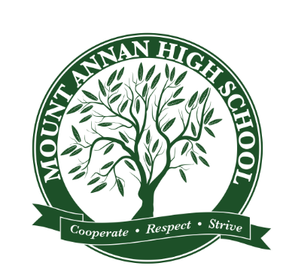**MOUNT ANNAN HIGH SCHOOL**

248 Welling Drive, Mount Annan NSW 2567

PO Box 50 Narellan NSW 2567

Phone (02) 4648 0111 Fax (02) 4648 0042

EMAIL: [mountannan-h.school@det.nsw.edu.au](mailto:mountannan-h.school@det.nsw.edu.au)

**Cyberia Online Safety Education Program YEAR 7**

Dear Parents and Carers,

All students in Year 7 have the opportunity to attend an incursion led by *Brainstorm Production* on Thursday 6th August 2020. They will be presenting a live performance for that explores **online safety**, **cyber bullying**, **resilience** and **mental health**. This engaging online safety and mental health program is aimed at high school students and incorporates live theatre to encourage positive relationships and help-seeking. The program is targeted at all Stage 4 students and focuses on showing students how they can come together to help make a positive difference in their school and make positive online choices.

**This program covers:**

|  |  |  |
| --- | --- | --- |
| * **Cyber Bullying** * **Digital Citizenship** * **Social Media** * **Online Privacy and Security** | * **Depression & Anxiety** * **Help- Seeking** * **Social Isolation** * **Responsible use of technology** | * **Gaming** * **Impulse Control** * **Digital Reputation** * **Cyber Safety** |

**WHEN:** Thursday 6th August 2020

**WHERE:** Mount Annan High School

**COST:** $7.00 each. Payable to the front office



____________________________________________________________________________________

*Please complete the form below and return it to the office by the due date.*

Consent form: ***Cyberia Online Safety Education Program*** Date due**: 5/08/2020**

I give my permission for my son/daughter *(please print full name)* …………………………………………………in roll call class ……..… to attend the *Cyberia show* on Thursday 6th August.

Parent’s signature ……………………………………….………………… Date ………………………………………….

**Payment Options:**

❏ I have enclosed the payment of **$7.00**

❏ OR Payment has been made by Direct Deposit* to the school account through the School Website

(date) ………………………..…. Receipt Number: ………………………..…………… (Reference: Student’s full name and class).